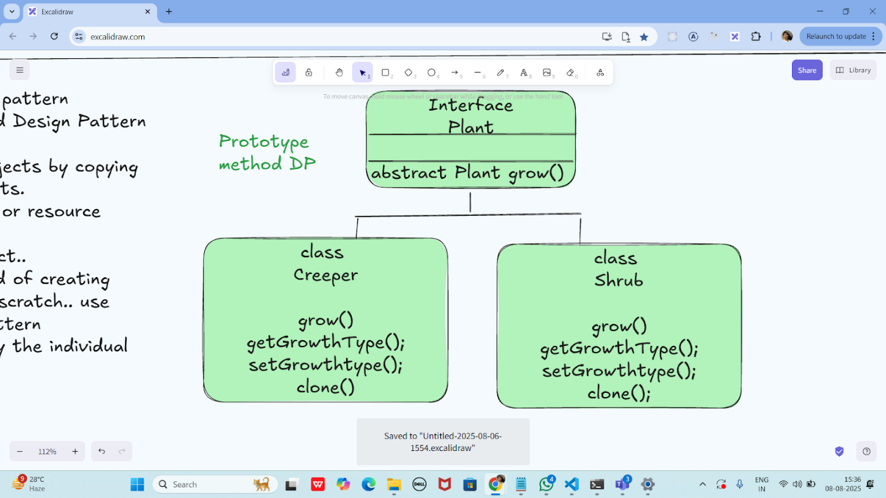

Code:

package com.example;

public interface Plant {

void grow();

Plant clone();

}

package com.example;

public class Creeper implements Plant {

private String growthType;

public Creeper() {

System.out.println("Creeper constructor is called");

}

public Creeper(String growthType) {

this.growthType = growthType;

}

@Override

public void grow() {

System.out.println("Creeper grows along the ground or other surfaces.");

}

public String getGrowthType() {

return growthType;

}

public void setGrowthType(String growthType) {

this.growthType = growthType;

}

@Override

public Plant clone() {

return new Creeper(this.growthType);

}

}

package com.example;

public class Shrub implements Plant {

private String growthType;

public Shrub() {

System.out.println("Shrub constructor is called");

}

public Shrub(String growthType) {

this.growthType = growthType;

}

@Override

public void grow() {

System.out.println("Shrub grows with multiple woody stems from the ground.");

}

public String getGrowthType() {

return growthType;

}

public void setGrowthType(String growthType) {

this.growthType = growthType;

}

@Override

public Plant clone() {

return new Shrub(this.growthType);

}

}

package com.example;

public class Main {

public static void main(String[] args) {

// Original prototypes

Plant creeperPrototype = new Creeper("Horizontal Growth");

Plant shrubPrototype = new Shrub("Bushy Growth");

// Cloning

Plant clonedCreeper = creeperPrototype.clone();

Plant clonedShrub = shrubPrototype.clone();

// Modify clones if needed

if (clonedCreeper instanceof Creeper) {

((Creeper) clonedCreeper).setGrowthType("Climbing Growth");

}

if (clonedShrub instanceof Shrub) {

((Shrub) clonedShrub).setGrowthType("Dense Bush");

}

// Usage

System.out.println("Creeper growth type: " + ((Creeper) clonedCreeper).getGrowthType());

clonedCreeper.grow();

System.out.println("Shrub growth type: " + ((Shrub) clonedShrub).getGrowthType());

clonedShrub.grow();

}

}

Output:

Creeper growth type: Climbing Growth

Creeper grows along the ground or other surfaces.

Shrub growth type: Dense Bush

Shrub grows with multiple woody stems from the ground.

Process finished with exit code 0